**Assignment 3**

1. Create 4 instance ( one master and 3 slave)

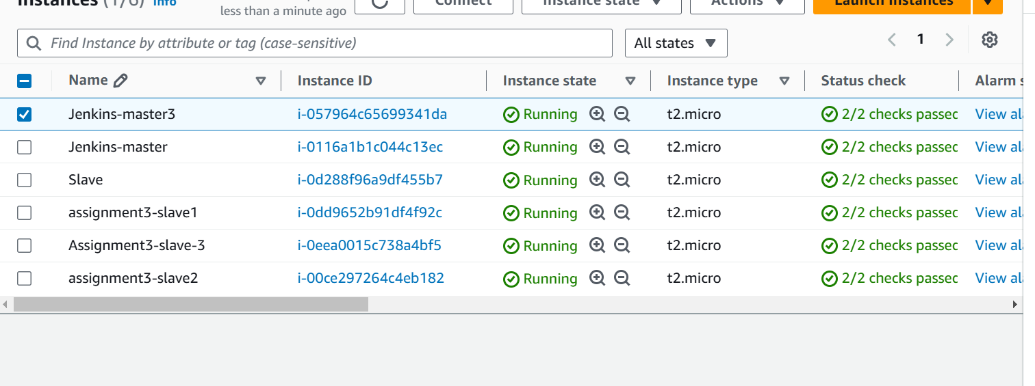

1. Login master and install java , Apache tomcat and Jenkins
2. After that open Jenkins and configure slave
3. First login on all slave and install java and git as well as create remote repository
4. Then configure all slave through SSH.
5. Login on master and create 3 branches
6. In all branches create jenkinsfile
7. pipeline{
8. agent{
9. label {
10. label "Slave-1"
12. }
13. }
14. stages{
15. stage("install httpd"){
16. steps{
17. sh '''
18. sudo yum install httpd -y
19. sudo systemctl start http
20. '''
21. }
22. }
23. stage("deploy httpd"){
24. steps{
25. sh '''
26. sudo chmod -R 777 /var/www/html
27. echo "This is Branch -1 Test web appliation" > /var/www/html/index.html
28. '''
29. }
30. }


34. }

37. }

pipeline{

    agent{

        label {

            label "Slave-2"

        }

    }

    stages{

        stage("install httpd"){

            steps{

                sh '''

            sudo yum install httpd -y

            sudo systemctl start httpd

            '''

            }

        }

         stage("deploy httpd"){

            steps{

                sh '''

                sudo chmod -R 777 /var/www/html

                echo "This is Branch -1 Test web appliation" > /var/www/html/index.html

                '''

            }

         }

    }

}

pipeline{

    agent{

        label {

            label "Slave-3"

        }

    }

    stages{

        stage("install httpd"){

            steps{

                sh '''

            sudo yum install httpd -y

            sudo systemctl start httpd

            '''

            }

        }

         stage("deploy httpd"){

            steps{

                sh '''

                sudo chmod -R 777 /var/www/html

                echo "This is Branch -1 Test web appliation" > /var/www/html/index.html

                '''

            }

         }

    }

}

8. after that Push all branches on github.

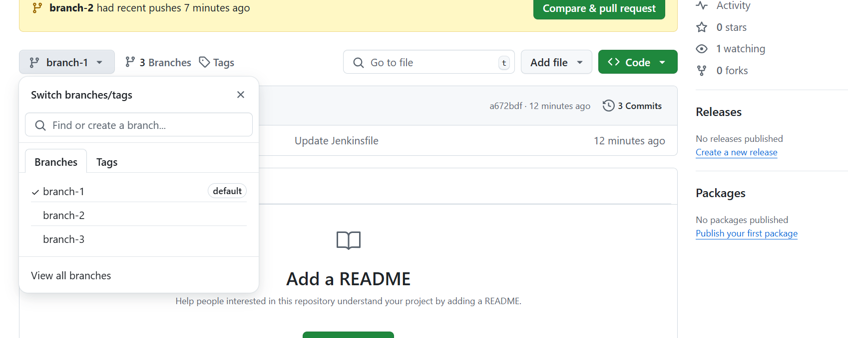

9. create new project 🡪 name 🡪multibranch pipeline 🡪add source 🡪 git 🡪 <https://github.com/tusharchavan412/Pipeline.git> 🡪save

10. then build now and check any error

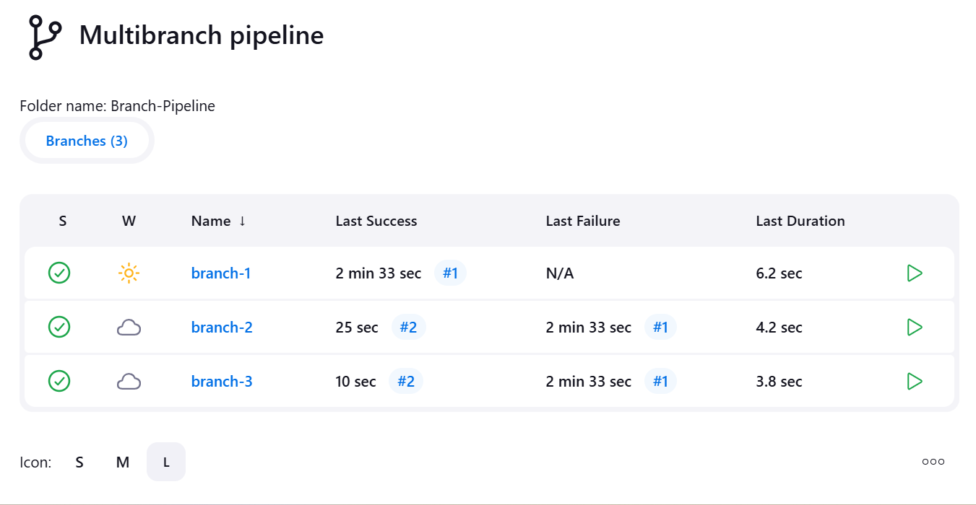

11. hit all slave public IP address

